

CLOUD COMPUTING
BSE ( V-B )

Submitted By:
Musfira Farooq
Roll No:
2023-BSE-045

ASSIGNMENT 02
Advanced Terraform & Nginx Multi-Tier Architecture

PART 01
Infrastructure Setup
1.1-Project Structure:

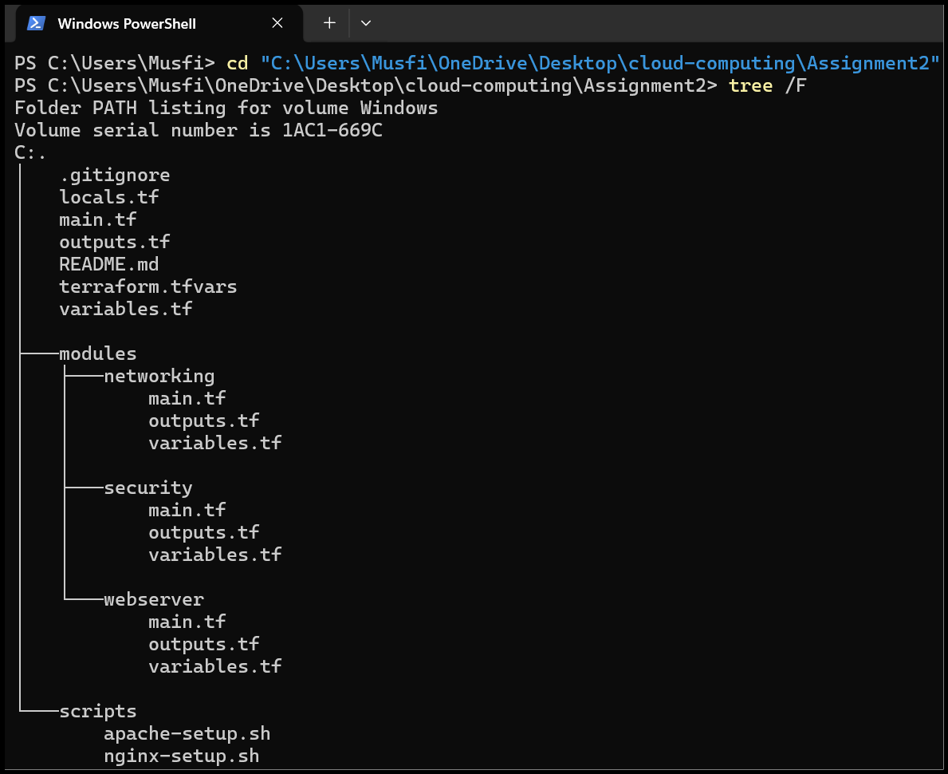
- content of .gitignore:

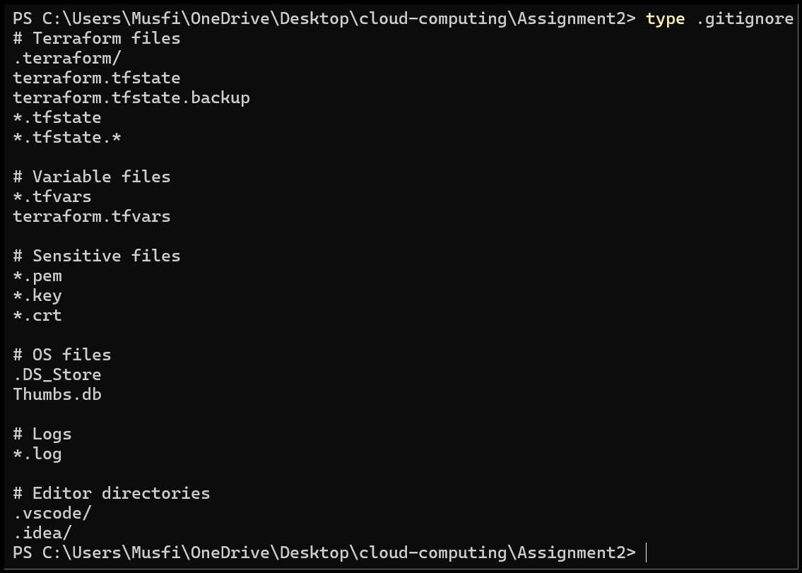
1.2-Variable Configuration:
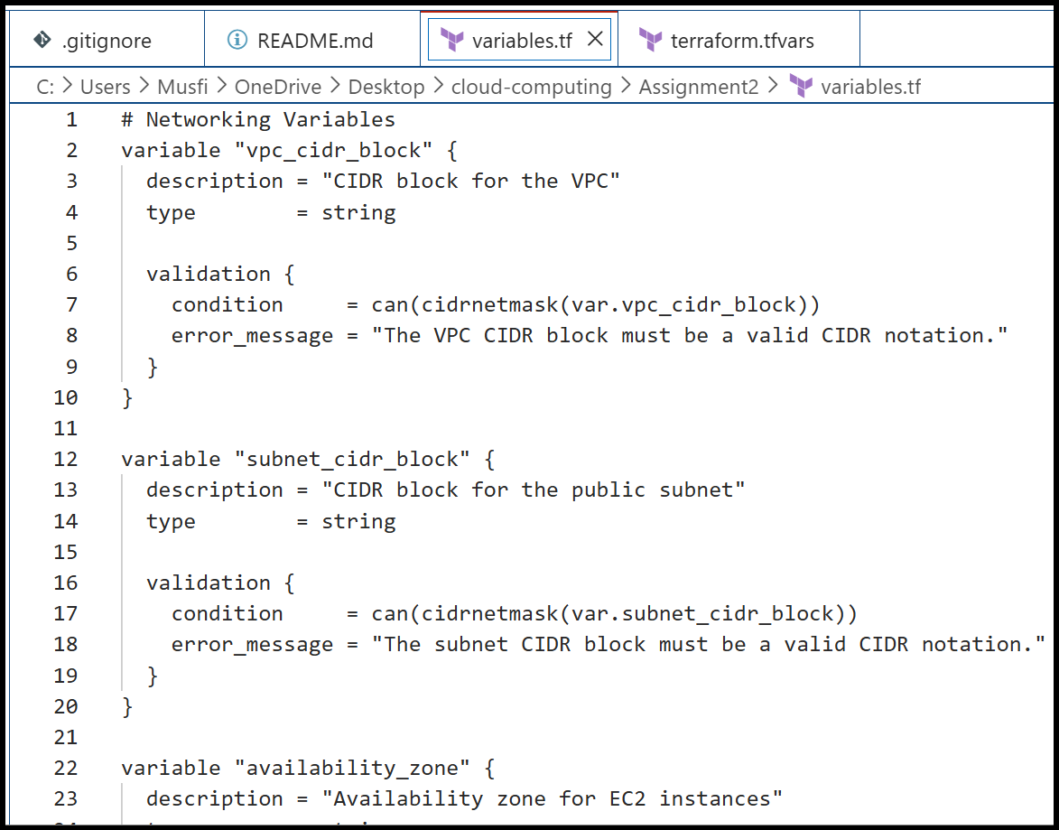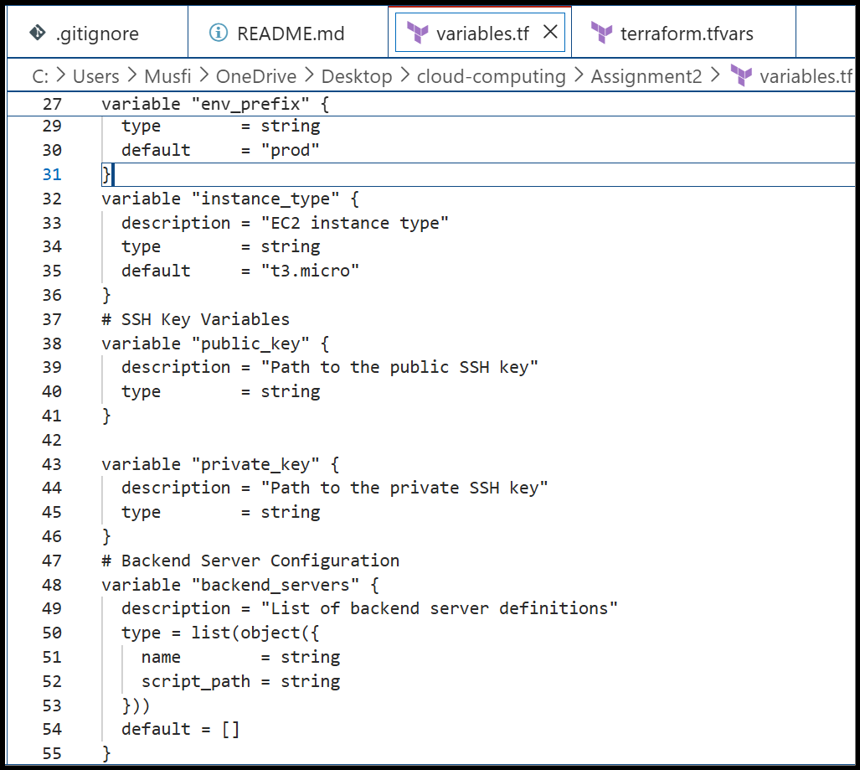
- terraform_tfvars:
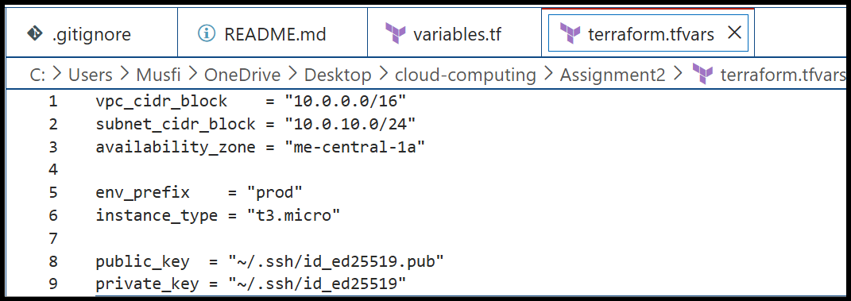
1.3 Networking Module:
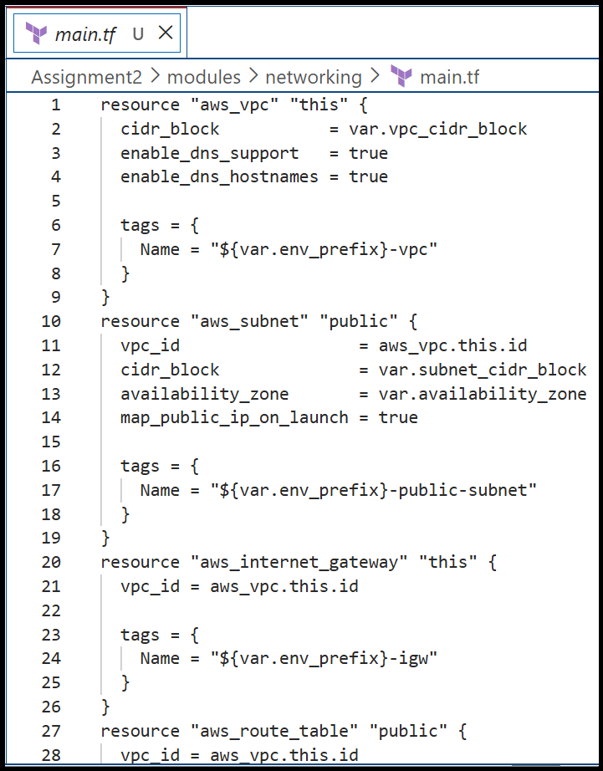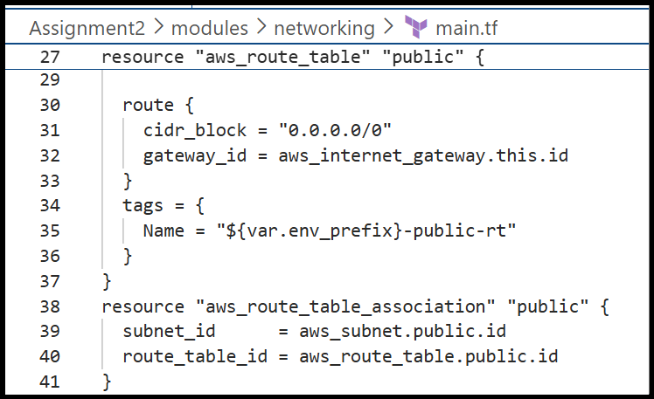
- networking_module_outputs:
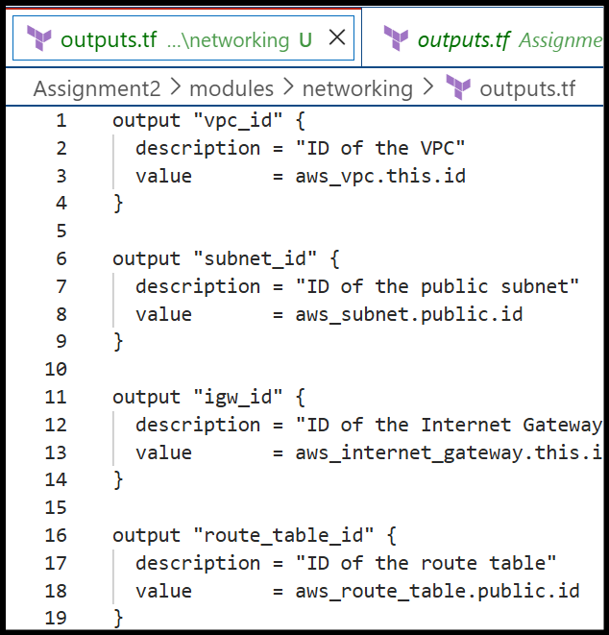

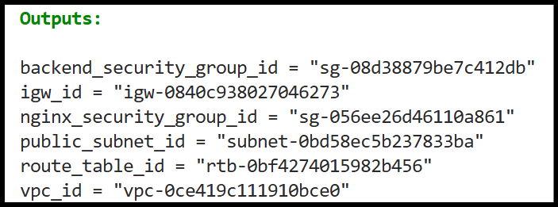
1.4 Security Module:
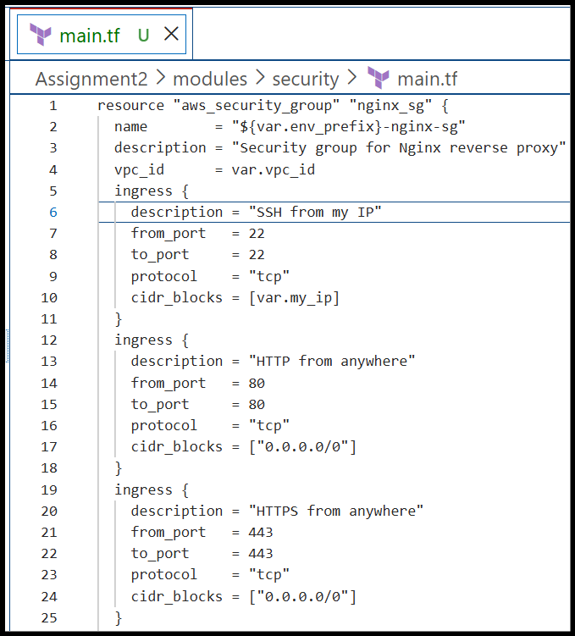
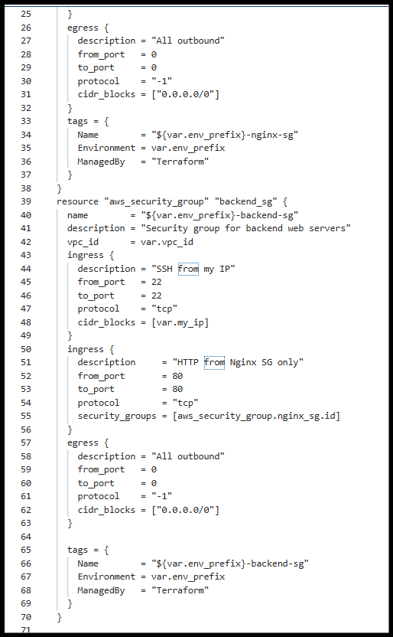
- AWS Console:
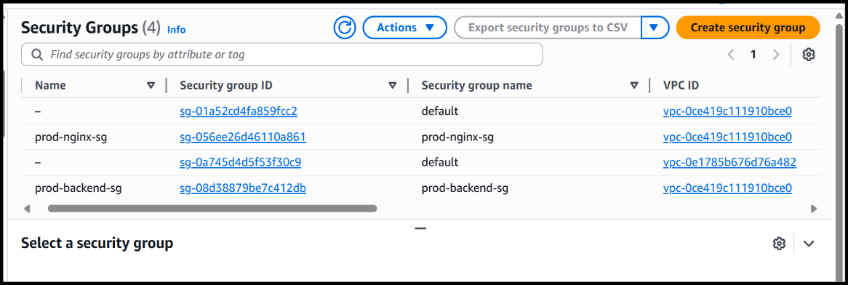
1.5 Locals Configuration:
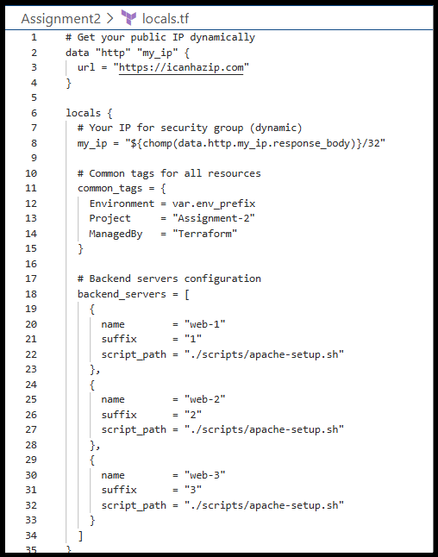
Part 02
Webserver Module
2.1 Module Design:
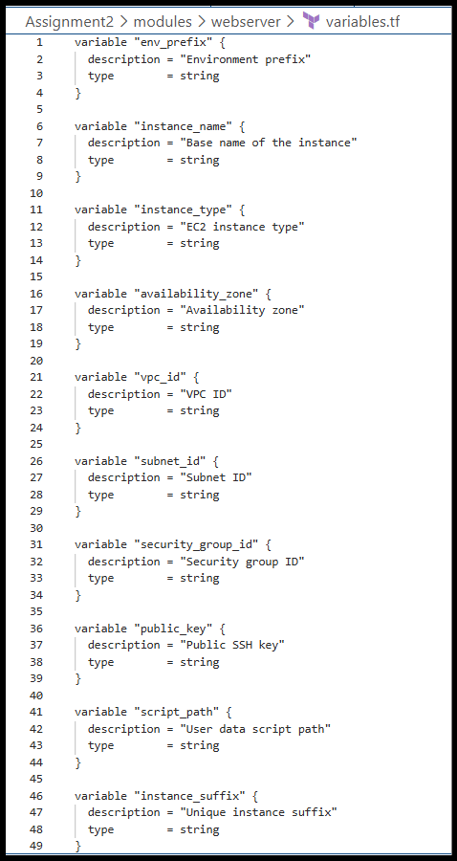
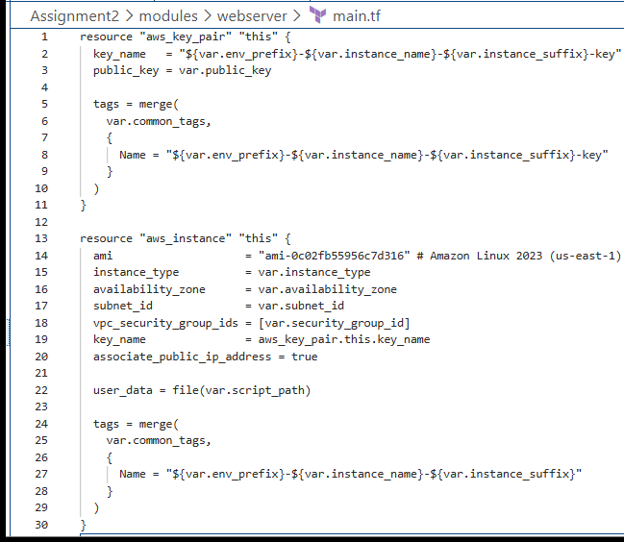
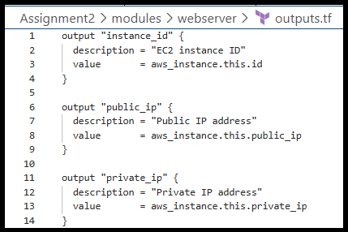
2.2 Module Usage:
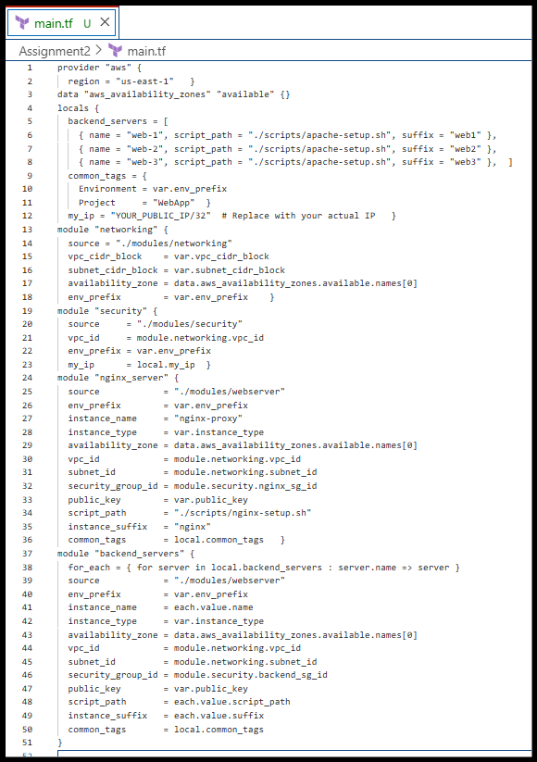
Part 3
Server Configuration Scripts
3.1 Apache Backend Server Script:

- browser showing backend server page:

3.2 Nginx Server Setup Script:

- before backend configuration:

